**Control structure’s**

Control structures are the building blocks that define the flow of execution in your JavaScript programs. They allow you to make decisions based on conditions, repeat code blocks, and handle errors gracefully. Here's a breakdown of the common control structures in JavaScript:

**Loops:**

* **for:** This loop is used for repetitive tasks where you know the number of iterations beforehand. It has three parts: initialization, condition, and increment/decrement.

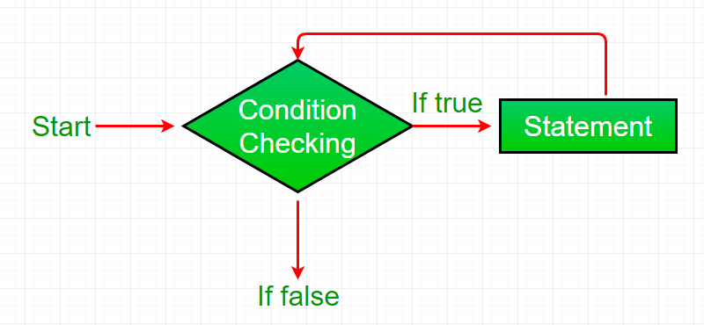

JavaScript

for (let i = 0; i < 5; i++) {

console.log("Iteration", i);

}

**While loop :** This loop continues executing a block of code as long as a specified condition remains true.

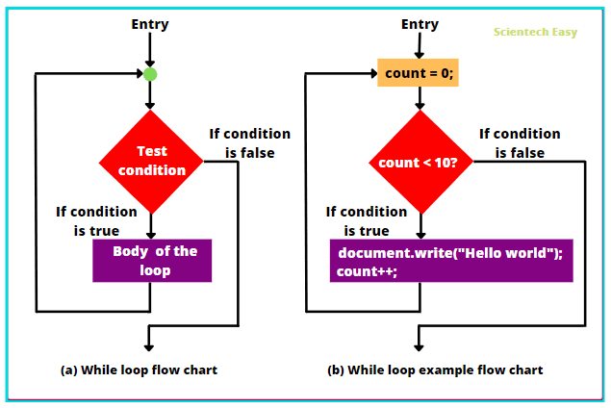

JavaScript

let count = 0;

while (count < 3) {

console.log("Count:", count);

count++;

}

**Do while loop :** Similar to while, but the code block will always execute at least once, even if the condition is initially false.

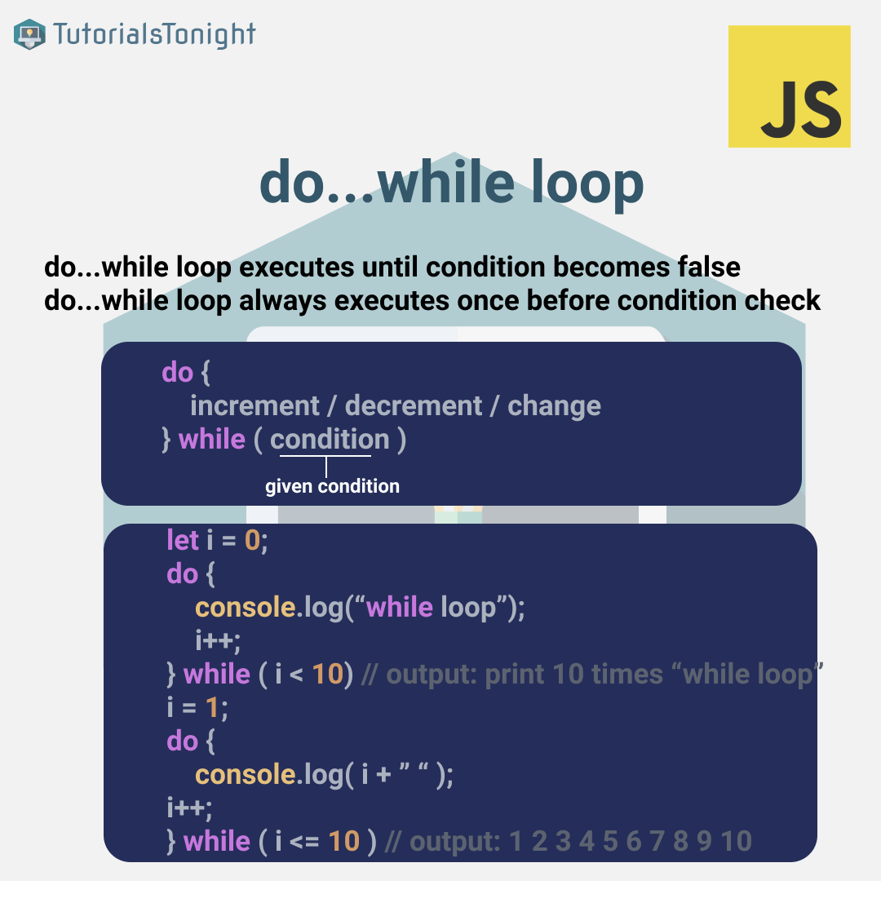

example

let count = 1;

**do** {

  console.log(count);

  count++;

} **while** (count <= 5);